Smart School System Portal for Students/Parents

# Attendance report. (Student’s attendance):

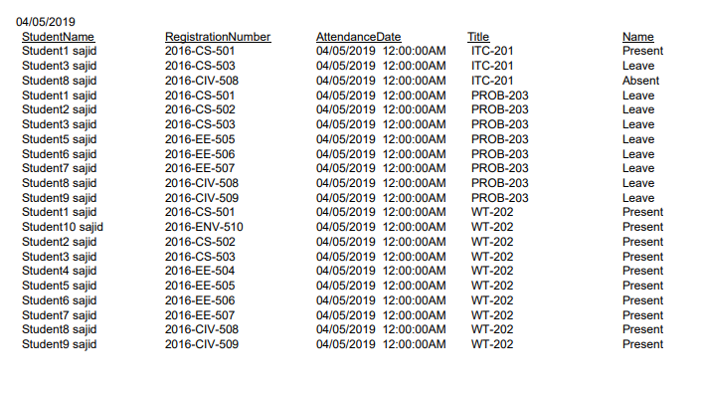

# Dues summary. (Fee remaining and submitted details):

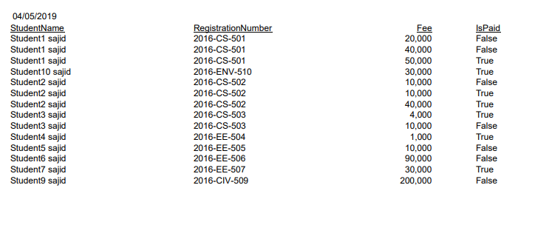

# Subject result. (Containing the result of student in a subject):

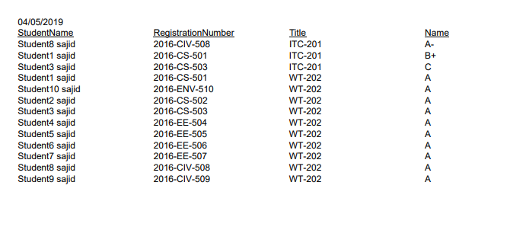

# Hostel details. (Containing all the information about hostel):

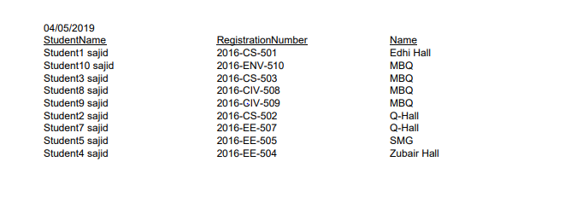

# Registered Courses. (The courses in which student is registered):

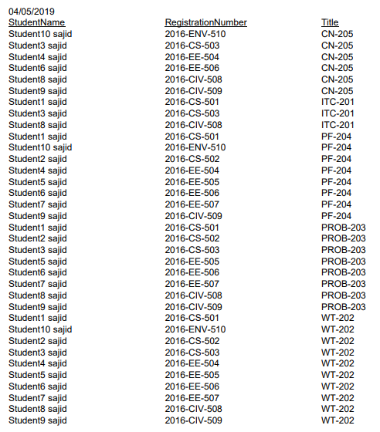

# Joined events. (Events like Parent Teachers Meeting, Farewell etc.):

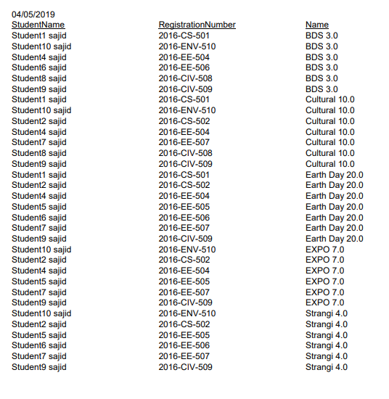

# Complain reports. (Student’s complains):

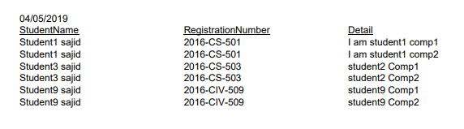

# Leave report. (Leaves taken by the student):

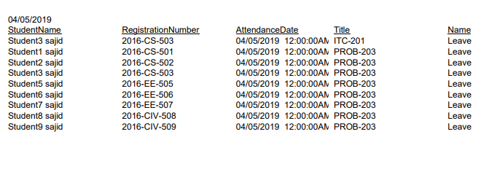

# Challan report. (Challan of Student):

